UACluster 2 project overview

All information including features, integration, and support is subject to change at *any* time.

Contents

Introduction 3

Virtual Machine creation script 4

VMClusterManager Utility 5

HPC Cluster Web site 12

# Introduction

UACluster2 is set of manuals and tools to create and manage high performance computing cluster based on Microsoft Hyper-V virtual machines. It needs Microsoft HPC Server 2008 (Microsoft HPC Server 2008 R2) as a basis of cluster creation.

The topicality of the project is based on following facts:

* In most of the offices personal computers (PC) are not used about 70 % of a possible time resource.
* Computational capability of processors of the PC was almost balanced with server’s one because in most cases they are built on the same kernels and have the same frequency.
* For the local area network organization between computing cluster nodes there is widespread Gigabit Ethernet technology. It completely meets requirements to construction of a network of an exchange on Message Passing Interface (MPI) protocol both on capacity and on parameters of delays.
* Hardware based virtualization technologies progress and widespread expansion
* Graphics Processing Unit (GPU) computations invocation perspectives

The aim of the project is providing users with essential documentation and tools for fast and easy creation of HPC cluster with following features:

* Algorithmically universal computing system
* Easy and fast system deployment
* Ability to use PCs for computing tasks and users working simultaneously
* Easy and fast computing system reconfiguration without making any changes to hardware configurations
  + "Hot" computing system reconfiguration
  + Means for creation of optimized computing system configurations for certain task requirements (e. g. OpenMP tasks or MPI tasks)
* Optimization of hardware resources utilization
* Prospects for creating new configurations as a result of virtualization platform improvements in future

UACluster2 currently consists of following components with corresponding documentations:

* PowerShell script for fast Virtual Machine HPC nodes creation and deployment
* VMClusterManager Utility for management of the cluster
* Web site of the cluster containing Web interface which allows users submit tasks to the cluster and view various reporting information

Let’s consider UACluster2 components in more details.

# Virtual Machine creation script

The script allows you automatically create virtual machines (VM) with specified parameters. You can specify following:

* name for VMs (all VMs will have the same name)
* amount of processor cores, which your virtual machines will use
* amount of RAM for each VM
* virtual hard drive size
* list of host's IP address where virtual machines will be located (one VM per host)

For more information about script operation, please, go to [UACluster2 deployment documentation](http://uacluster2.codeplex.com/documentation).

# VMClusterManager Utility

The VMClusterManager is configuration and management utility for UACluster2 HPC Computing Cluster based on Hyper-V Virtual Machines (CCVM). It is designed to meet following requiremens:

* Unified user interface for all CCVM aspects handling, such as physical computers (PC), Virtual Machines (VM), Microsoft Hyper-V, tasks that are running on the cluster and so on.
* PC and VM bulk management and monitoring ability within LAN.
* Tasks bulk monitoring and controlling ability.
* User accounts and CCVM resources access policies management ability.
* Ability to protect the cluster from intentional or accidental injury by means of Operating System OS.

VMClusterManager version 1.0 has following functionality:

* VM hosts management
  + Adding and removing hosts
  + VM host’s CPU and memory resources monitoring
  + VM hosts grouping
* VM management
  + VM location monitoring
  + VM grouping
  + VM state, snapshots, CPU and memory configuration monitoring and management
  + Connection to VM desktop
  + Getting job and task list running on selected VMs
  + VM bulk management
* HPC job and task management
  + Cancelling and requeueing jobs which are running on selected VMs
  + Cancelling and requeueing tasks which are running on selected VMs

See Fig. 1-6 for VMClusterManager GUI details.

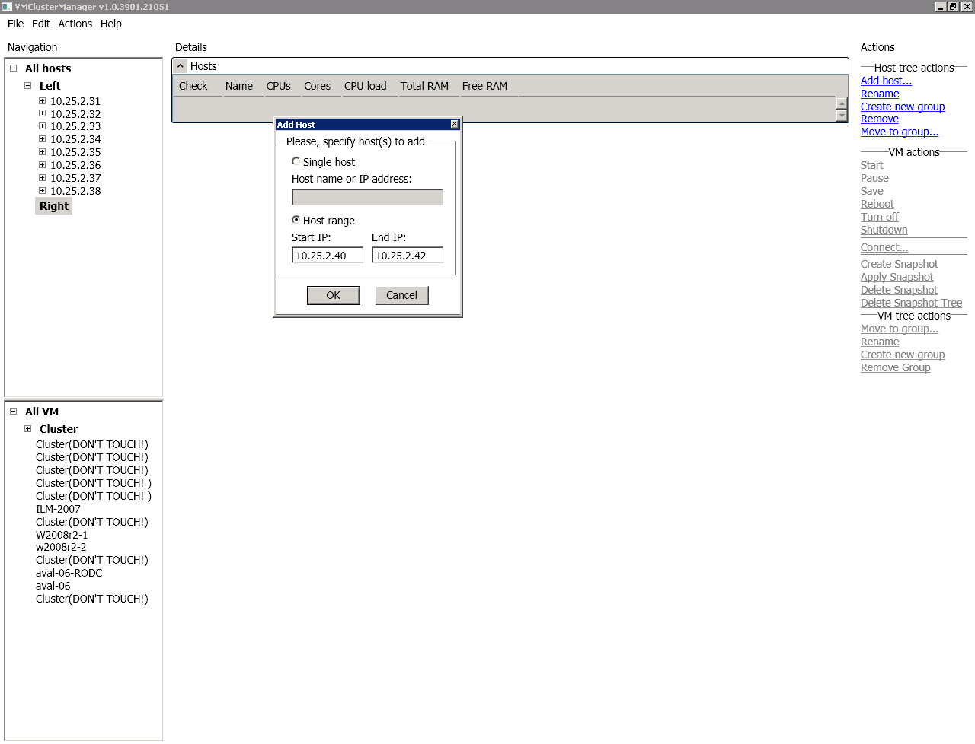

Fig. 1 Adding new hosts as children of “Right” group.

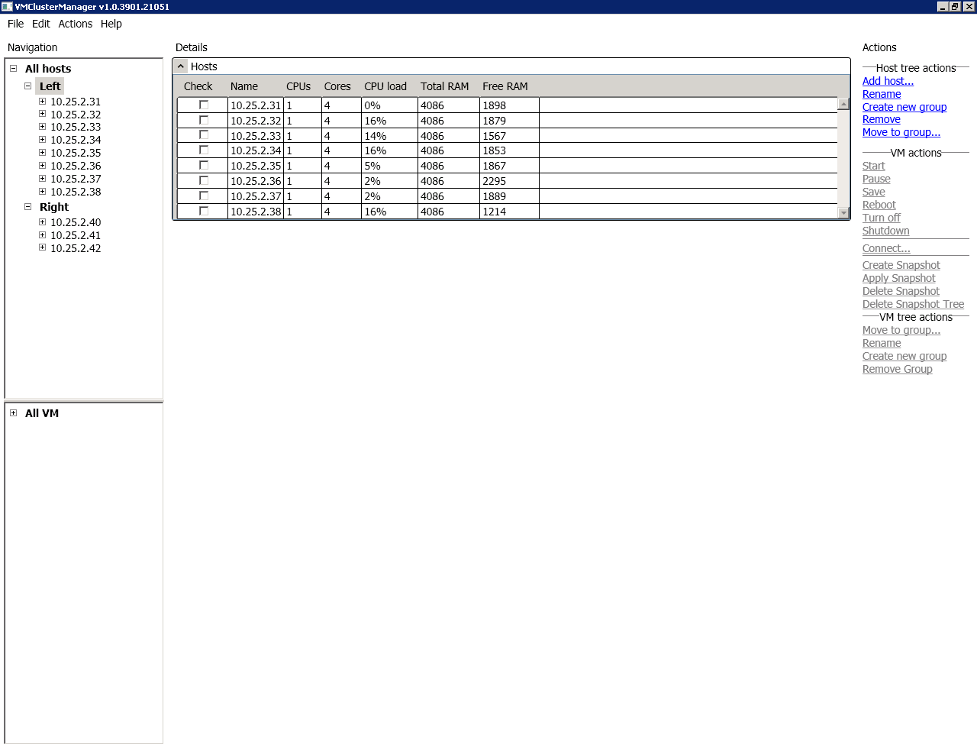

Fig. 2 Host's resources monitoring.

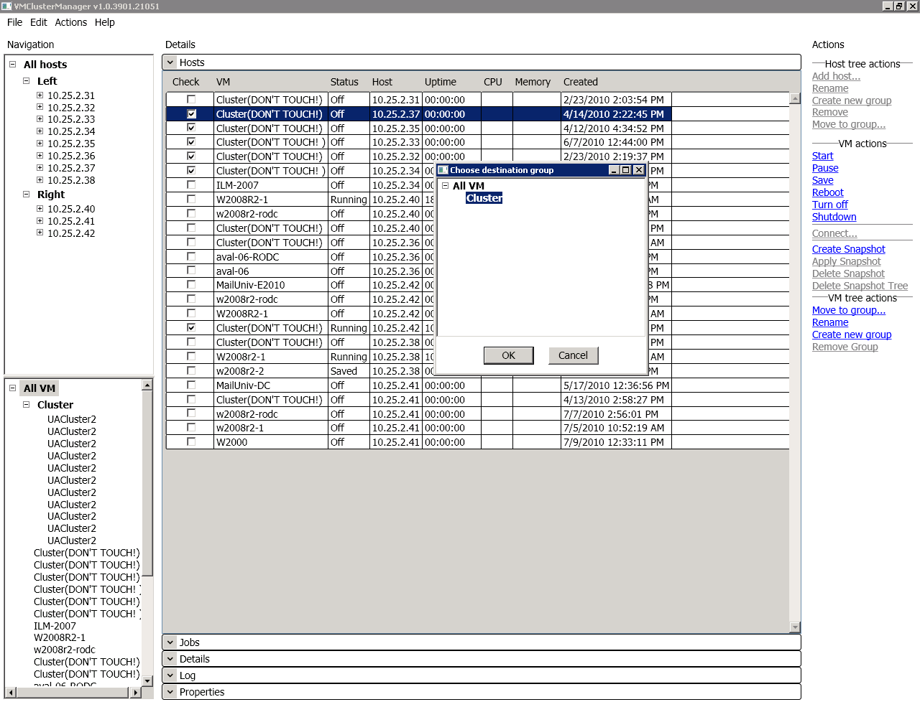

Fig. 3 Virtual Machine list management. Moving selected Virtual Machines to another group.

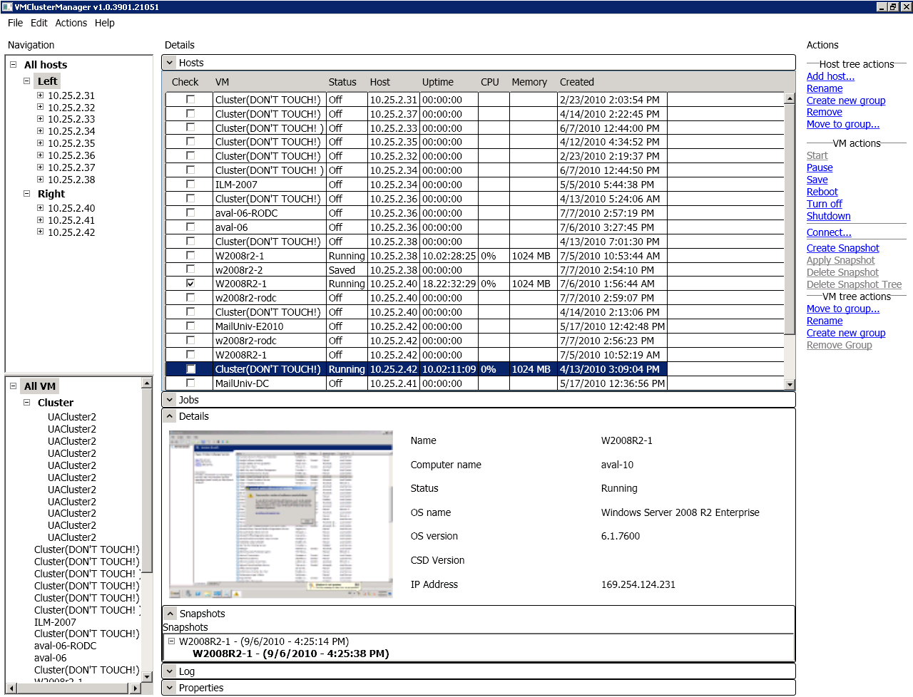

Fig. 4 Virtual Machine details exploration.

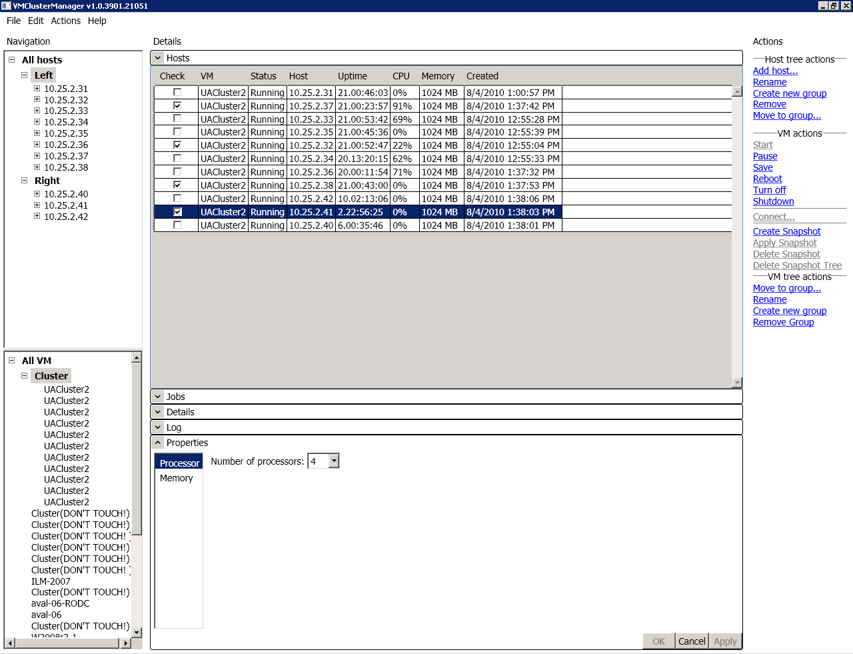

Fig. 5 Virtual Machine list management. Properties for selected Virtual Machines.

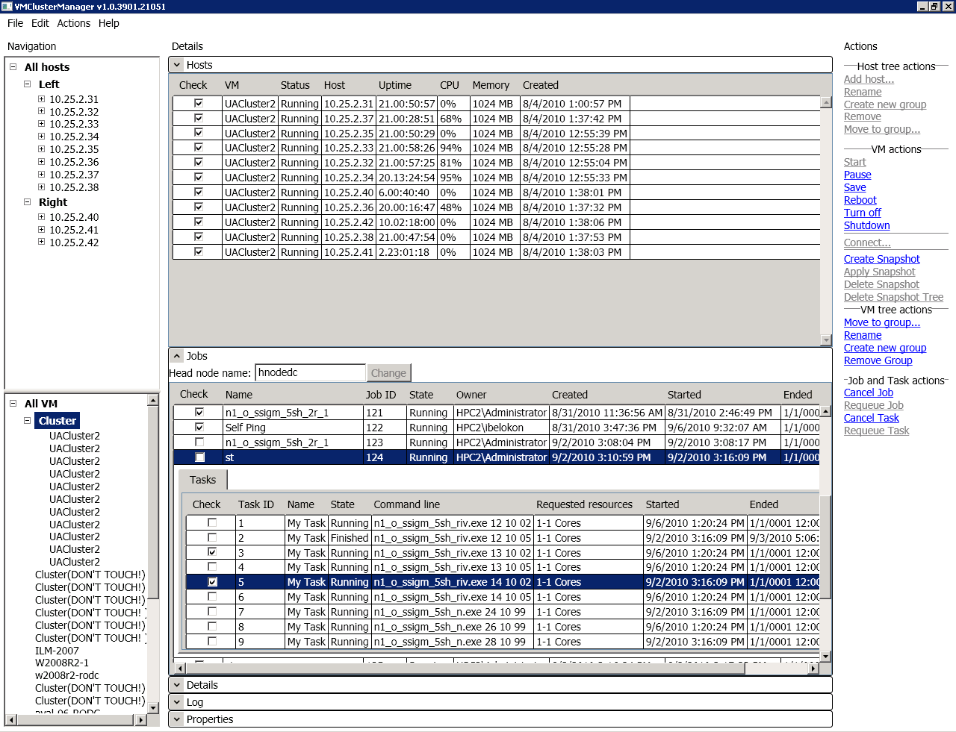

Fig. 6 HPC job and task management for selected Virtual Machine list.

# HPC Cluster Web site

The HPC Cluster Web Site is created to allow users to configure, submit and monitor their HPC jobs via Internet avoiding access to cluster’s local network.

The Web site features are:

* HPC Jobs and Tasks bulk submitting, monitoring and controlling ability.
* File Manager for user working directory.
* Cluster’s availability and congestion statistics.
* Information pages for various purposes such as FAQ and scheduler.

Web-interface currently available only in Ukrainian. See Fig. 7- 11 for Web interface details.

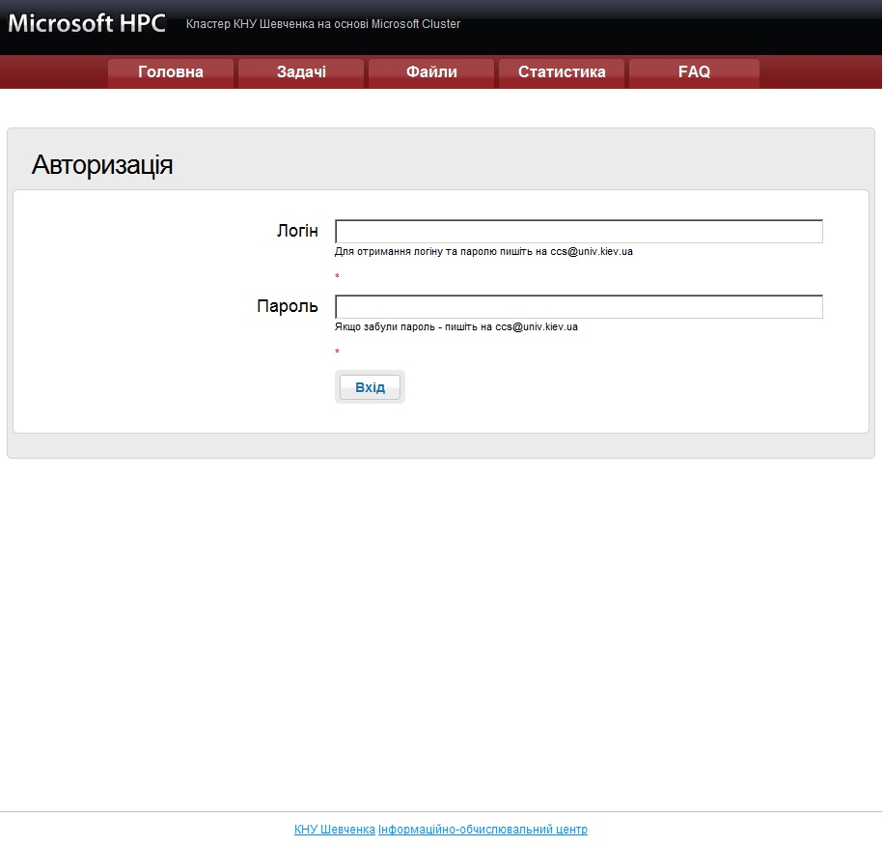

Fig. 7 User login page.

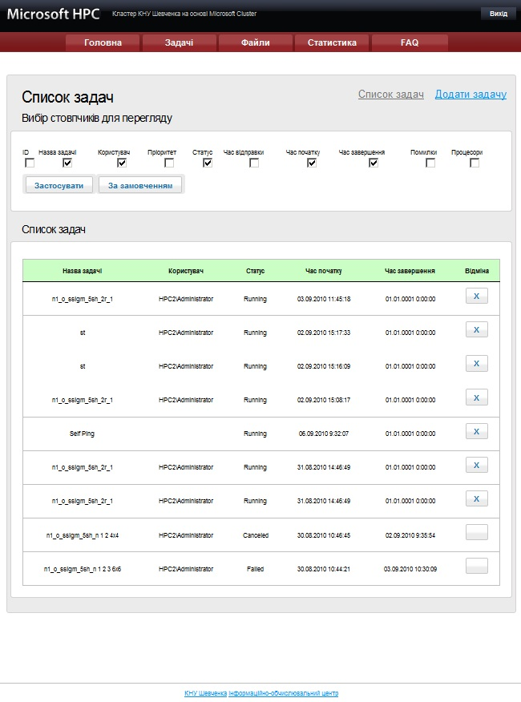

Fig. 8 Exploring user's jobs.

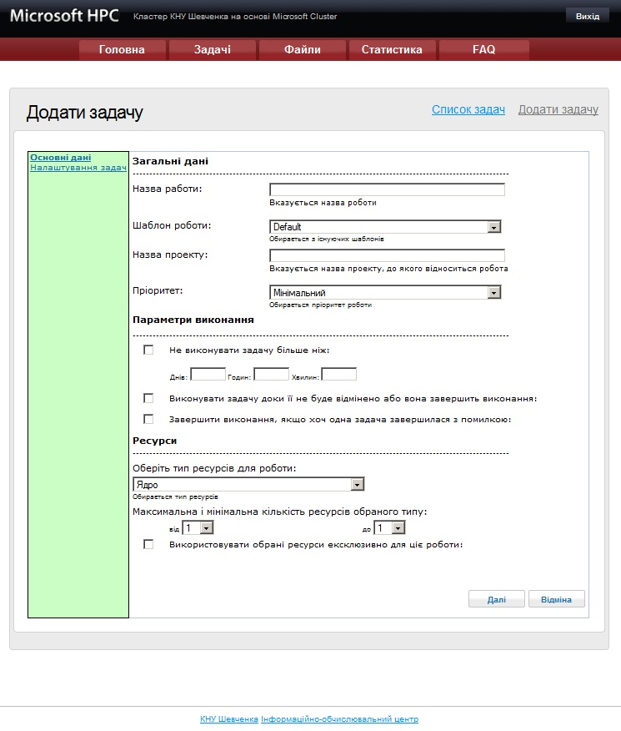

Fig. 9 New Job dialogue.

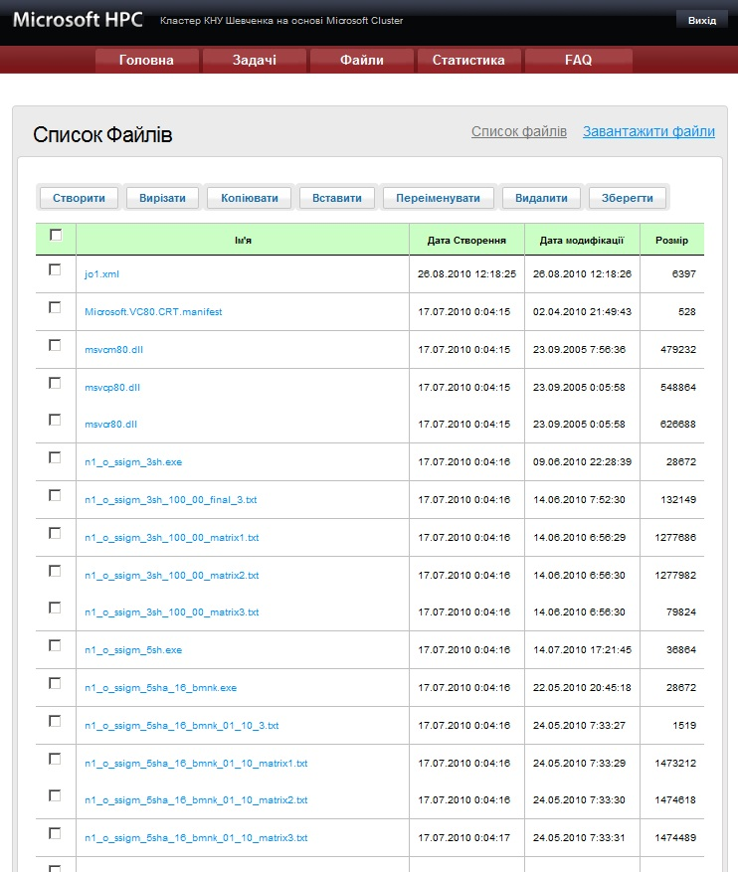

Fig. 10 File manager for user's working directory.

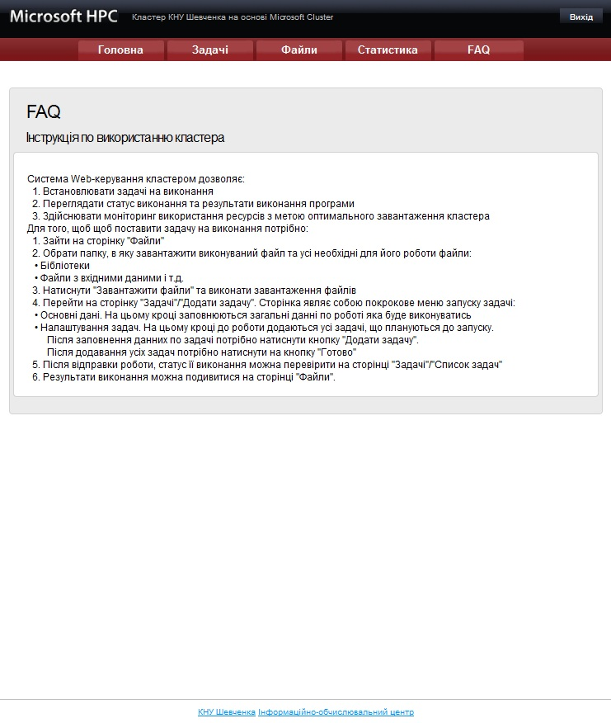

Fig. 11 FAQ page.